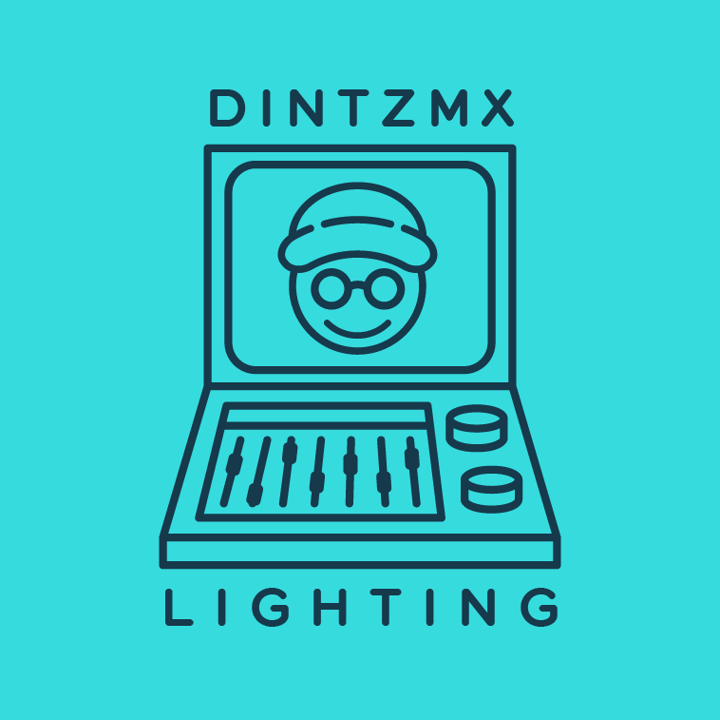

LIGHTING CONTROL

DMX/CRMX Hardware
Item | Qty | Day Rate
- RatPac AKS+ (Single Universe Transmitter) | 1 | $70
- RatPac Cintenna 2 (Single Universe Transceiver) | 1 | $30
- LumenRadio Luna (Transceiver) | 1 | $50
- Enttec ODE MKIII (2 Universe|DMX to Ethernet Node) | 1 | $20
- PKnight 40 Amp AC Dimmer | 1 | $15
- Aputure MC Pro (Receiver) | 1 | $15
- Aputure DMX Dongle (for MC/MT Pro) | 1 | $5
- DMX Cable 3-FT (5-Pin Female XLR to 5-Pin Male XLR) | 1 | $10
- Neutrik NA3F5M (3-Pin Female XLR to 5-Pin Male XLR) | 1 | $5
- Neutrik NA5MM-B (5-Pin Male XLR to 5-Pin Male XLR) | 1 | $5

Networking Hardware
Item | Qty | Day Rate
- Arris Surfboard Wi-Fi Router (400 Mbps) | 1 | $10
- Belkin USB-C to Ethernet Hub | 1 | $5
- CAT 8 Flat Ethernet Cable 1-FT (x2) | 1 | $5
- CAT 6 Ethernet Cable 25-FT | 1 | $5

Lighting Console Software
Item | Qty | Day Rate
- Blackout Lighting Console App | 1 | $30
- Luminair App | 1 | $15

Lighting Console Hardware
Item | Qty | Day Rate
- Apple M4 iPad Pro 13” | 1 | $40
- Apple M2 iPad Air 11” | 1 | $20
CAMERA

Camera
Item | Qty | Day Rate
- Sony FX30 | 1 | $40
- SmallRig Cage + Handle | 1 | $10
- Sony NP-FZ100 | 1 | $10
- Powerextra NP-FZ100 | 3 | $5
- Powerextra NP-FZ100 Charger | 1 | $5

Lenses
Item | Qty | Day Rate
- Sony 15mm F/1.4 G | 1 | $50
- Sony 35mm F/1.8 | 1 | $25
- Sony 18-105mm F/4 G | 1 | $25
- Sigma 56mm F/1.4 | 1 | $25
- Sirui Nightwalker 24mm F/1.2 | 1 | $20
- Sirui Nightwalker 35mm F/1.2 | 1 | $20
- KMZ Helios 58mm F/2 | 1 | $20

Monitor
Item | Qty | Day Rate
- Atomos Ninja V | 1 | $20
- SmallRig Atomos Ninja V Cage | 1 | $5
- Alvin’s Cables Atomos Locking DC to D-Tap Power Cable | 1 | $5
- Atomos mSATA SSD (500GB) | 1 | $10
- StarTech USB-C to mSATA Reader | 1 | $5
- ANDYCINE Lunchbox mSATA SSD (1TB) | 1 | $15
- ANDYCINE USB-C to mSATA Reader | 1 | $5
- SmallRig HDMI Cable | 1 | $5

AUDIO

Hard-Line Audio
Item | Qty | Day Rate
- Sony XLR-H1 Handle | 1 | $30
- Rode NTG-2 | 1 | $20
- Tascam DR-40X | 1 | $10
- Neewer Boom Pole (Internal XLR) with Shock Mount | 1 | $10

Wireless Audio
Item | Qty | Day Rate
- Hollyland Lark Max | 1 | $30
- Hollyland Lavalier Microphones | 2 | $10
- Shure MVL Lavalier Microphones | 2 | $20
- SC3 3.5mm TRRS to TRS Cable Adapter | 2 | $5

For rentals needing 3+ Days/Weekend Rates, please reach out!
Willing to negotiate deals depending on project kind and budget!

Mobile: +1 (773) 441-8287
Email: dintzmx@gmail.com

